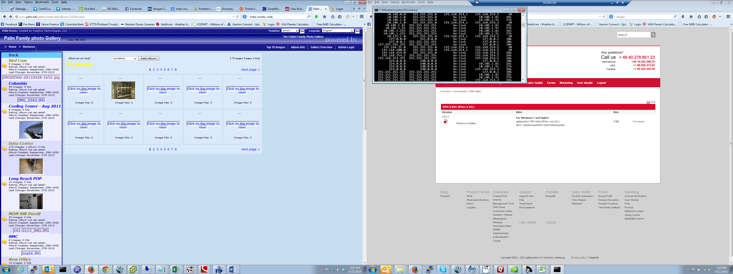

I was able to access each of the images on the screen I attempted, I selected next page which was page 2.

I see a bunch of the following in the log /var/log/httpd/error_log_palin

[Wed Jun 11 17:15:48 2014] [error] [client 50.137.190.103] client denied by server configuration: /home/palin/public_html/gallery/show.php, referer: http://www.palin.net/gallery/index.php?album=%2FBusiness%2F&page=2
[Wed Jun 11 17:15:48 2014] [error] [client 50.137.190.103] client denied by server configuration: /home/palin/public_html/gallery/show.php, referer: http://www.palin.net/gallery/index.php?album=%2FBusiness%2F&page=2
[Wed Jun 11 17:15:48 2014] [error] [client 50.137.190.103] client denied by server configuration: /home/palin/public_html/gallery/show.php, referer: http://www.palin.net/gallery/index.php?album=%2FBusiness%2F&page=2
[Wed Jun 11 17:15:48 2014] [error] [client 50.137.190.103] client denied by server configuration: /home/palin/public_html/gallery/show.php, referer: http://www.palin.net/gallery/index.php?album=%2FBusiness%2F&page=2
[Wed Jun 11 17:15:48 2014] [error] [client 50.137.190.103] client denied by server configuration: /home/palin/public_html/gallery/show.php, referer: http://www.palin.net/gallery/index.php?album=%2FBusiness%2F&page=2
[Wed Jun 11 17:15:48 2014] [error] [client 50.137.190.103] client denied by server configuration: /home/palin/public_html/gallery/show.php, referer: http://www.palin.net/gallery/index.php?album=%2FBusiness%2F&page=2
[Wed Jun 11 17:15:48 2014] [error] [client 50.137.190.103] client denied by server configuration: /home/palin/public_html/gallery/show.php, referer: http://www.palin.net/gallery/index.php?album=%2FBusiness%2F&page=2
[Wed Jun 11 17:15:48 2014] [error] [client 50.137.190.103] client denied by server configuration: /home/palin/public_html/gallery/show.php, referer: http://www.palin.net/gallery/index.php?album=%2FBusiness%2F&page=2
[Wed Jun 11 17:15:48 2014] [error] [client 50.137.190.103] client denied by server configuration: /home/palin/public_html/gallery/show.php, referer: http://www.palin.net/gallery/index.php?album=%2FBusiness%2F&page=2
[Wed Jun 11 17:15:48 2014] [error] [client 50.137.190.103] client denied by server configuration: /home/palin/public_html/gallery/show.php, referer: http://www.palin.net/gallery/index.php?album=%2FBusiness%2F&page=2
[Wed Jun 11 17:15:48 2014] [error] [client 50.137.190.103] client denied by server configuration: /home/palin/public_html/gallery/show.php, referer: http://www.palin.net/gallery/index.php?album=%2FBusiness%2F&page=2
[Wed Jun 11 17:15:48 2014] [error] [client 50.137.190.103] client denied by server configuration: /home/palin/public_html/gallery/show.php, referer: http://www.palin.net/gallery/index.php?album=%2FBusiness%2F&page=2
[Wed Jun 11 17:15:48 2014] [error] [client 50.137.190.103] client denied by server configuration: /home/palin/public_html/gallery/show.php, referer: http://www.palin.net/gallery/index.php?album=%2FBusiness%2F&page=2
[Wed Jun 11 17:15:49 2014] [error] [client 50.137.190.103] client denied by server configuration: /home/palin/public_html/gallery/index.php, referer: http://www.palin.net/gallery/index.php?album=%2FBusiness%2F&page=2

When I attempted to click where the image should have been but was not there I get the following in my web browser.

Forbidden

You don't have permission to access /gallery/index.php on this server.
Apache/2.2.15 (CentOS) Server at www.palin.net Port 80

